Odoo Inventory – Assembled Products

Contents

What is an Assembled Product? 1

Creating the Assembled Product 1

Create the Assembled Product 1

Creating the BoM 2

Setting up a BoM for a Product with Sub-Assemblies 3

Configure the Top-Level Product BoM 4

Configure the Subassembly Product Data 4

Duplicating 4

# What is an Assembled Product?

An assembled product is a product that is built using multiple other products. Odoo does this via the manufacturing model. Inventory is tracked on each sub product as well as any product that has been assembled. Through the manufacturing process, the assembled product is built using multiple product on the bill of materials (BoM). After being assembled, inventory is removed from the sub products as they were used to create the assembled product and after manufacturing the assembled product, inventory is then tracked on that assembled product.

# Creating the Assembled Product

Assembled products are just normal products but are marked to go through the manufacturing process and will have bill of materials attached to them which contain the list of component products it takes to build the assembled product.

## Create the Assembled Product

To create an assembled product, the process is the same as any other product, however an assembled product is marked as ‘Manufacture’ in the inventory tab.

* Create a product using the **Inventory** or **Manufacturing** apps.
* In the **Inventory** tab, click **Manufacture.**
* Enter in all the other product details.
* If the component products don’t exist, those will need to be created before moving onto creating the BoM.

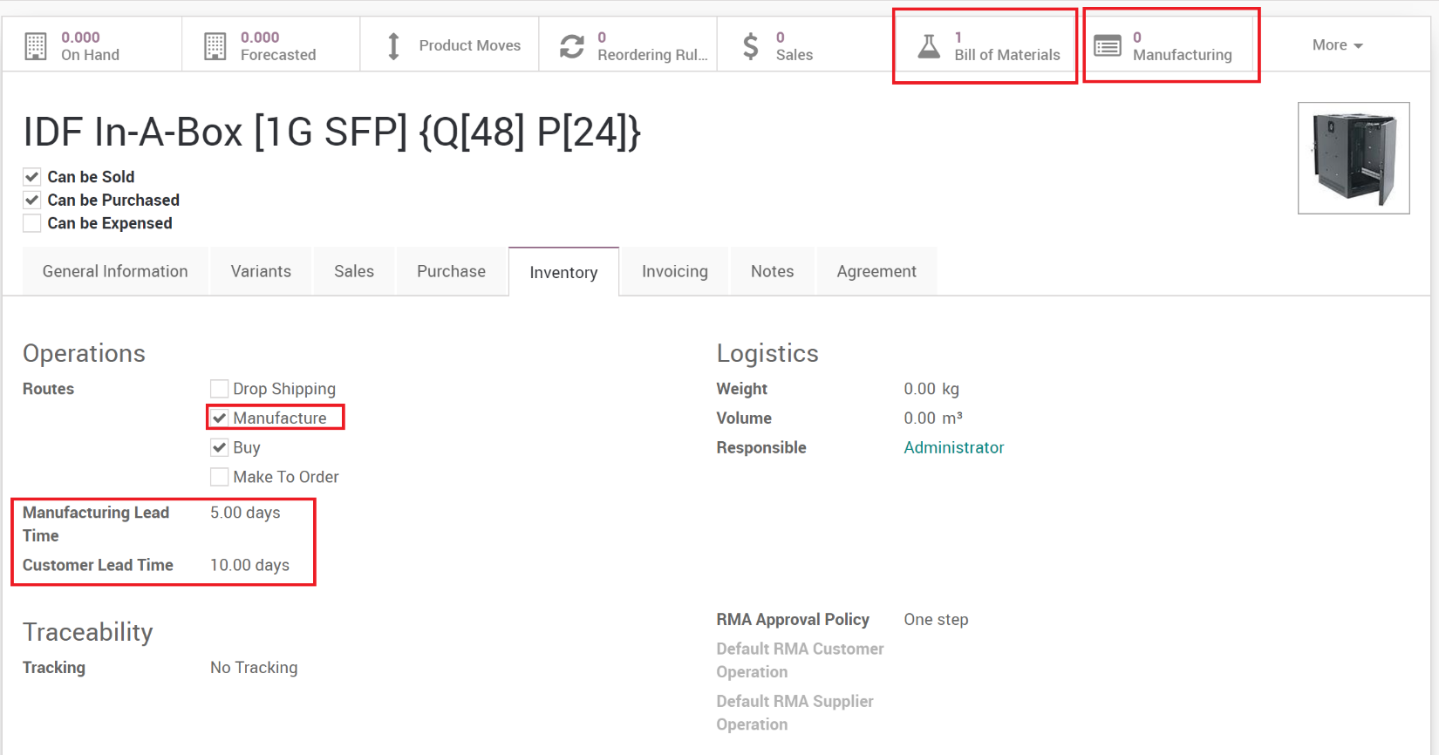

**Note**: Product Variants can also be used. The product is created the same way, along with its variants, then when building the BoM’s, each variant would contain it’s own BoM.

## Creating the BoM

Once your product is created, you can now create Bill of Materials (BoM) for the product. The BoM contains all the components of the assembled product.

* Click the **Bill of Materials** smart button.
* Edit an existing BoM or click **Create** to create a new one.

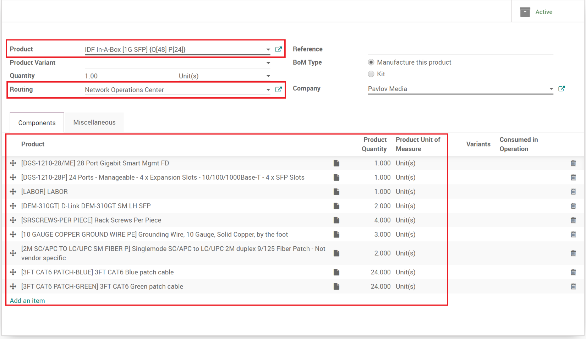

* Field Definitions
  + **Product**: The product the BoM belongs to.
  + **Product Variant**: The product variant of the master product that this BoM belongs to.
  + **Quantity**: The Quantity this BoM creates when completed.
  + **Routing**: The Work Center who will be assembling this product.
  + **Reference**: Internal reference.
  + **BoM Type**:
    - **Manufacture this product**: Goes through the manufacturing process.
    - **Kit**: Not assembled but placed together as a kit.
  + **Company:** In multi-company environments, if products are not shared then this is where you select the company that the BoM belongs to.
  + **Components**: Lists the components of the assembled product and their quantities.
  + **Miscellaneous**:
    - **Manufacturing Readiness**: How to calculate when the product is ready to be manufactured.
    - **Operation**: What operation in the manufacturing process this belongs to.

# Setting up a BoM for a Product with Sub-Assemblies

A subassembly is a manufactured product which is intended to be used as a component of another manufactured product. You may wish to employ sub-assemblies to simplify a complex BoM, to more accurately represent your manufacturing flow, or to use the same subassembly in multiple BoMs. A BoM that employs subassemblies is often referred to as a multi-level BoM.

Multi-level bills of materials in Odoo are accomplished by creating a top-level BoM and subassembly BoMs. Next, the procurement route of the subassembly product is defined. This ensures that every time a manufacturing order for the top-level product is created, a manufacturing order for each subassembly is created as well.

# Configure the Top-Level Product BoM

To configure a multi-level BoM, create the top-level product and its BoM. Include any subassemblies in the list of components. Create a BoM for each subassembly as you would for any product.

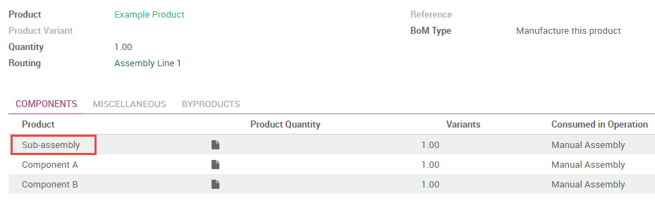

# Configure the Subassembly Product Data

On the product form of the subassembly, you must select the routes **Manufacture** and **Make To Order**. The **Manufacture** route takes precedence over the **Buy** route, so selecting the latter will have no effect.

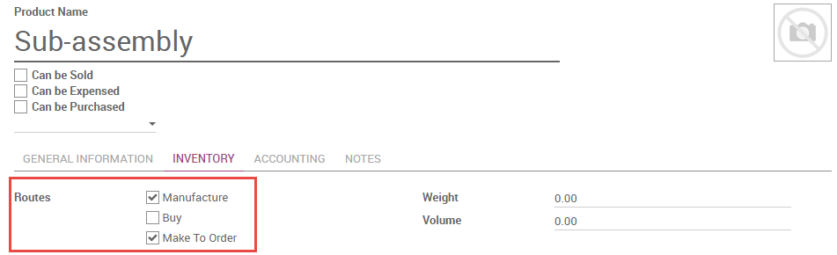

If you would like to be able to purchase the subassembly in addition to manufacturing it, select **Can be Purchased**. All other fields on the subassembly product form may be configured according to your preference.

# Duplicating

A quick way to make many similar products or BoM’s is by duplicating them. Any record can be duplicated via the action menu.

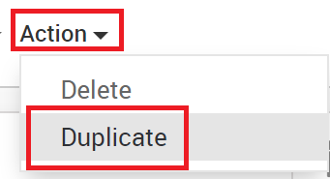

Once duplicated, the product or BoM can be updated for the new product.